Open Mixed Shapes
# Source: AI Source: Provided by: [Data Path: Persons Table -> ID Column: 1, Name_En Column: Motasem Essam] -> From: [ChatGPT] on [7/25/2026]
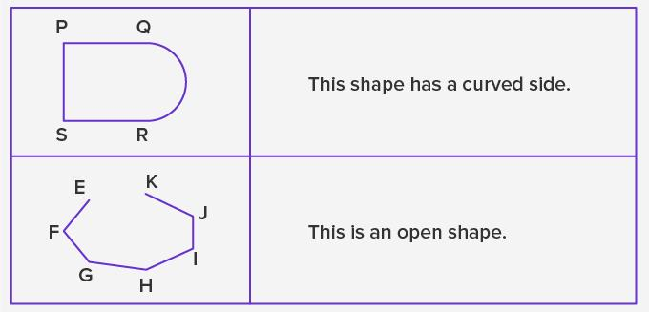
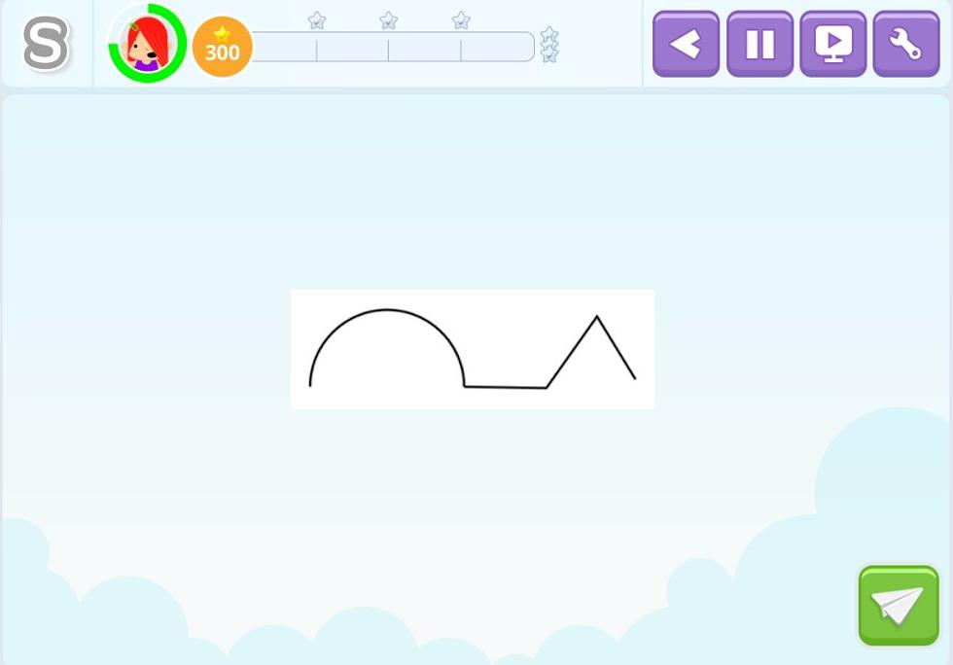
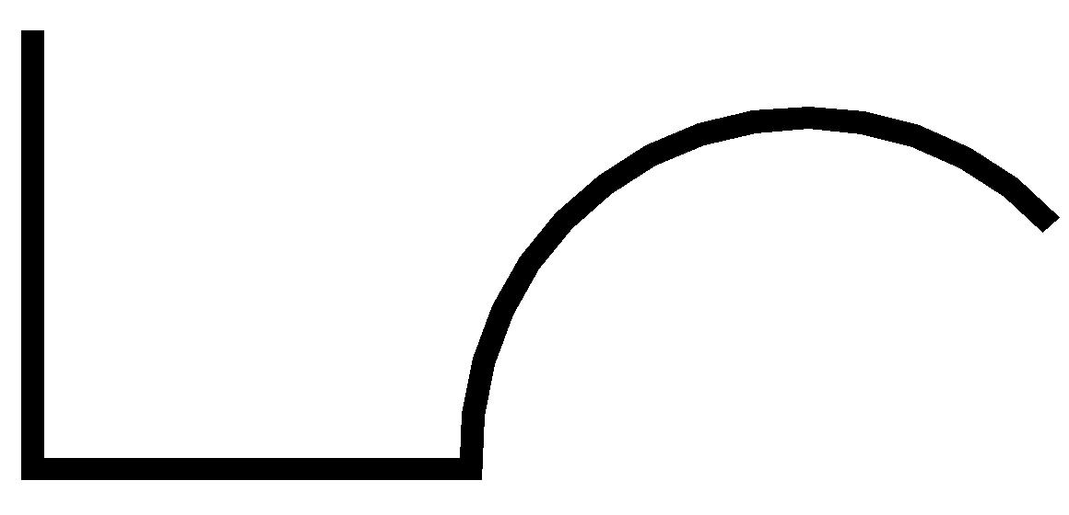

Definition
# Source: AI Source: Provided by: [Data Path: Persons Table -> ID Column: 1, Name_En Column: Motasem Essam] -> From: [ChatGPT] on [7/25/2026]
An Open Mixed Shape is an open plane figure composed of both straight and curved segments whose endpoints do not connect to form a closed boundary.
In simple terms:
It is an open path that combines straight-line and curved elements.
$$\boxed{\text{Open Mixed Shape}=\text{Open}+\text{Straight Elements}+\text{Curved Elements}}$$
For mathematical precision, these are often described as open mixed curves, open composite paths, or open paths with mixed boundaries rather than polygons.

Characteristics
# Source: AI Source: Provided by: [Data Path: Persons Table -> ID Column: 1, Name_En Column: Motasem Essam] -> From: [ChatGPT] on [7/25/2026]
An open mixed shape typically:
- Is open.
- Has two distinct endpoints.
- Contains both straight and curved portions.
- Does not enclose a bounded region by itself.
- Has a mixed boundary/path.
- May contain polygonal segments, circular arcs, or freeform curves.
- May be regular in some portions and irregular overall.
- Can be symmetric or asymmetric.
- Has a measurable total path length.
The defining condition is:
$$\boxed{P_{\text{start}}≠P_{\text{end}}}$$

Types of Open Mixed Shapes

1. Polygon–Circular Open Shapes
# Source: AI Source: Provided by: [Data Path: Persons Table -> ID Column: 1, Name_En Column: Motasem Essam] -> From: [ChatGPT] on [7/25/2026]
An open path combines straight polygonal segments with one or more circular arcs.
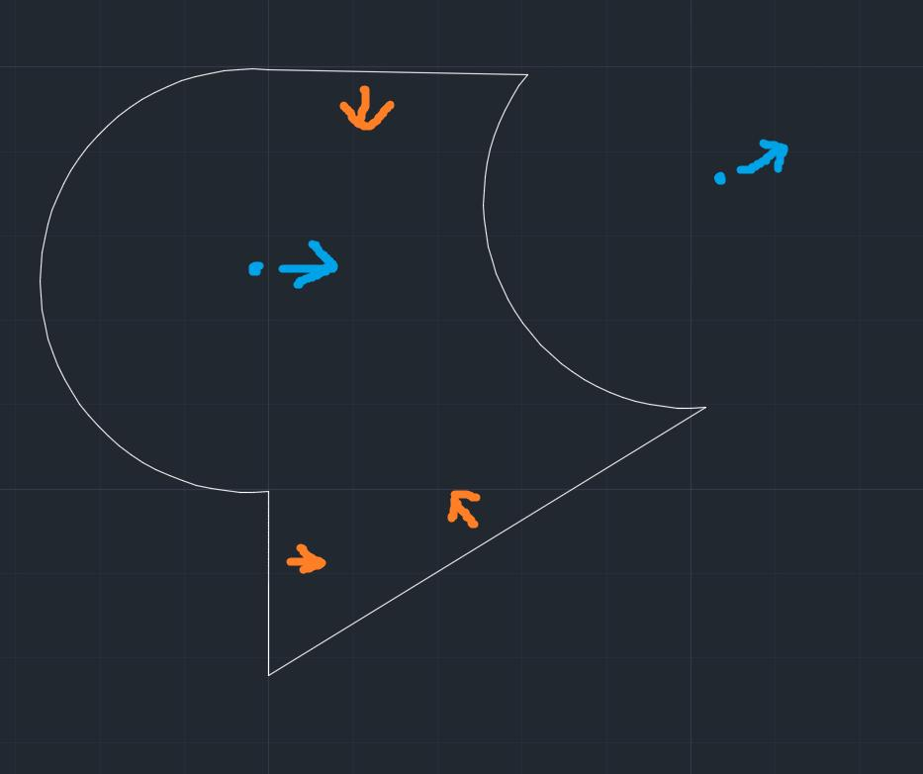
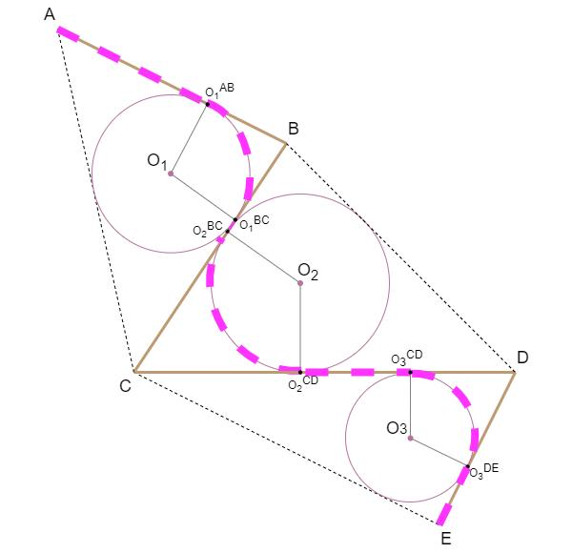
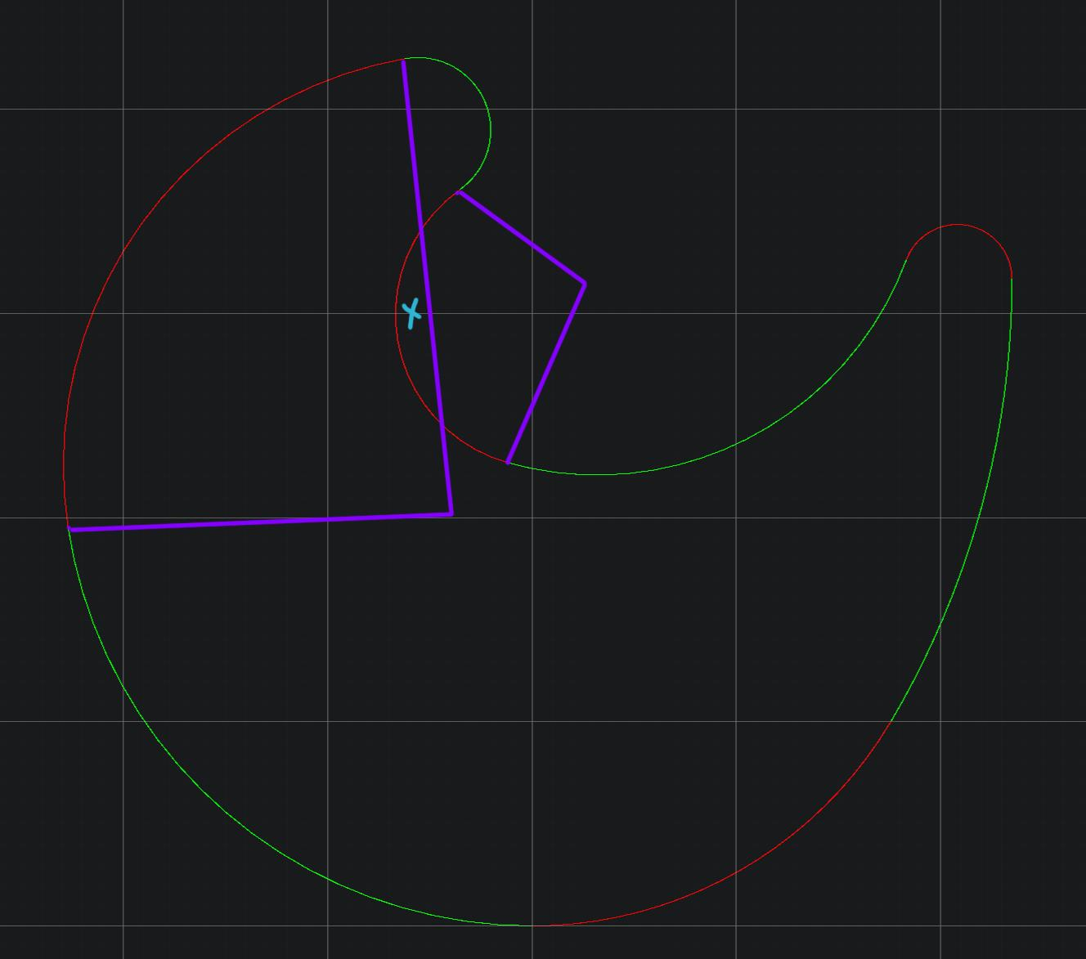
Example structure:
$$\text{Straight}→\text{Arc}→\text{Straight}$$
Possible examples include:
- Line + semicircular arc
- Polygonal segments + circular arc
- Zigzag + circular arc

2. Rectangle–Circular Open Shapes
# Source: AI Source: Provided by: [Data Path: Persons Table -> ID Column: 1, Name_En Column: Motasem Essam] -> From: [ChatGPT] on [7/25/2026]
An open path can contain horizontal or vertical segments together with circular arcs.
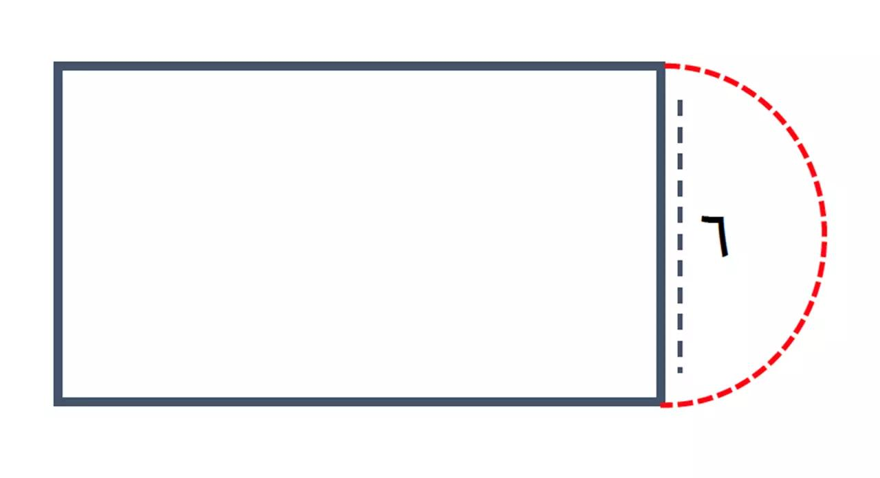
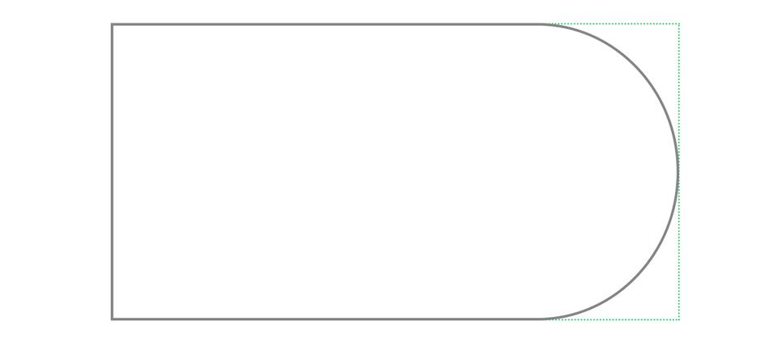
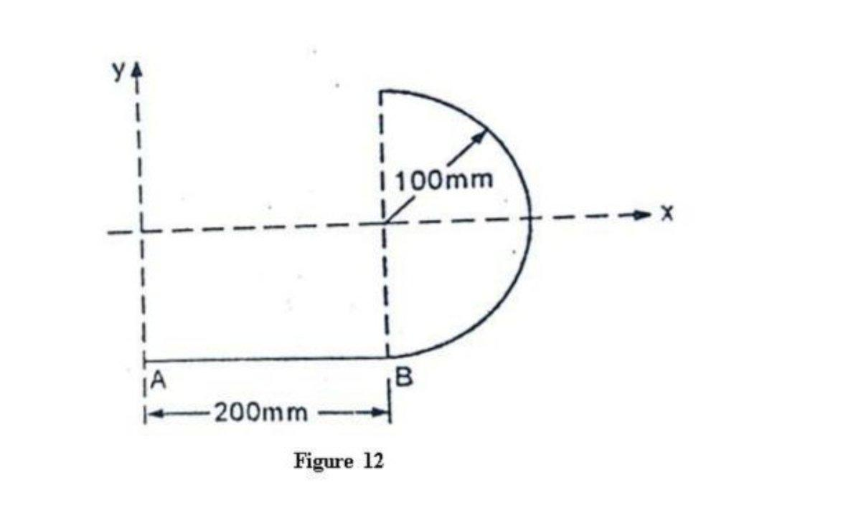
For example:
$$\text{Horizontal}→\text{Arc}→\text{Vertical}$$
This type is common in technical drawings and custom geometric paths.

3. Triangle–Circular Open Shapes
# Source: AI Source: Provided by: [Data Path: Persons Table -> ID Column: 1, Name_En Column: Motasem Essam] -> From: [ChatGPT] on [7/25/2026]
An open path may combine portions of triangular geometry with circular arcs.
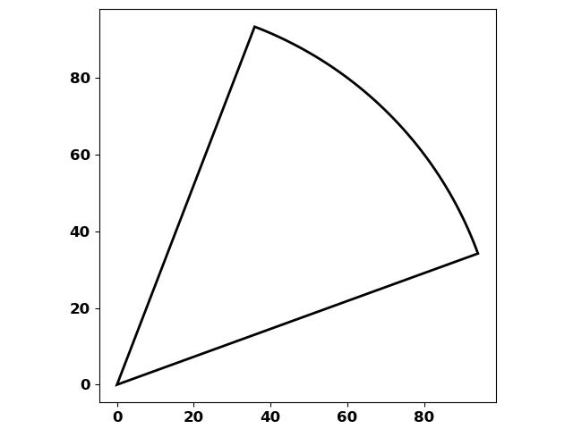
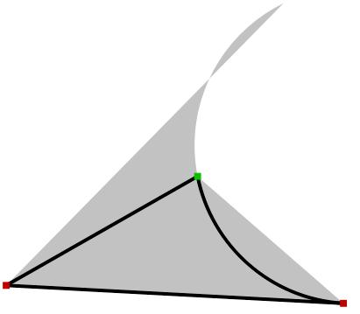
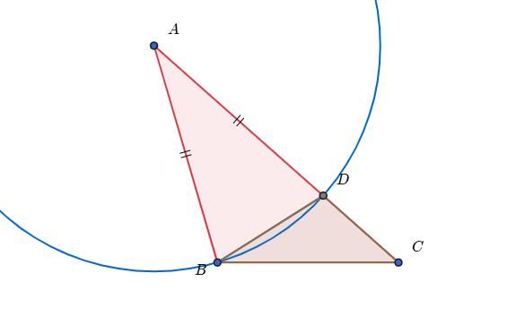
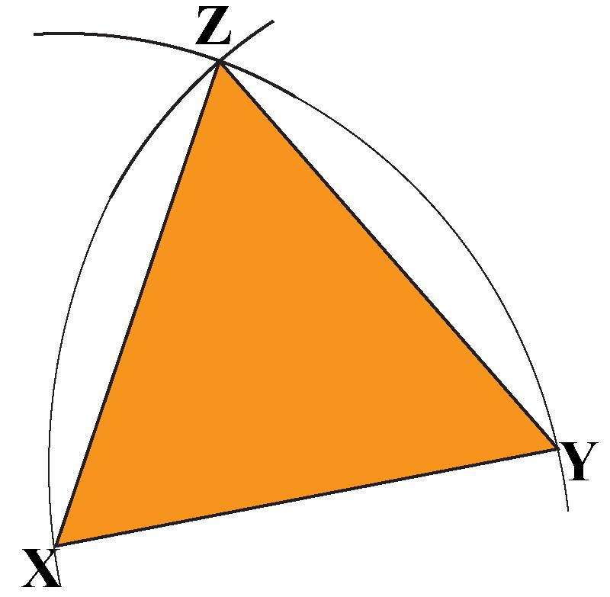
The path may contain:
- One or more straight triangular segments.
- One or more circular arcs.
- Two unconnected endpoints.

4. Polygon–Organic Open Shapes
# Source: AI Source: Provided by: [Data Path: Persons Table -> ID Column: 1, Name_En Column: Motasem Essam] -> From: [ChatGPT] on [7/25/2026]
A polygonal or straight-sided portion is combined with an organic-looking curved portion.
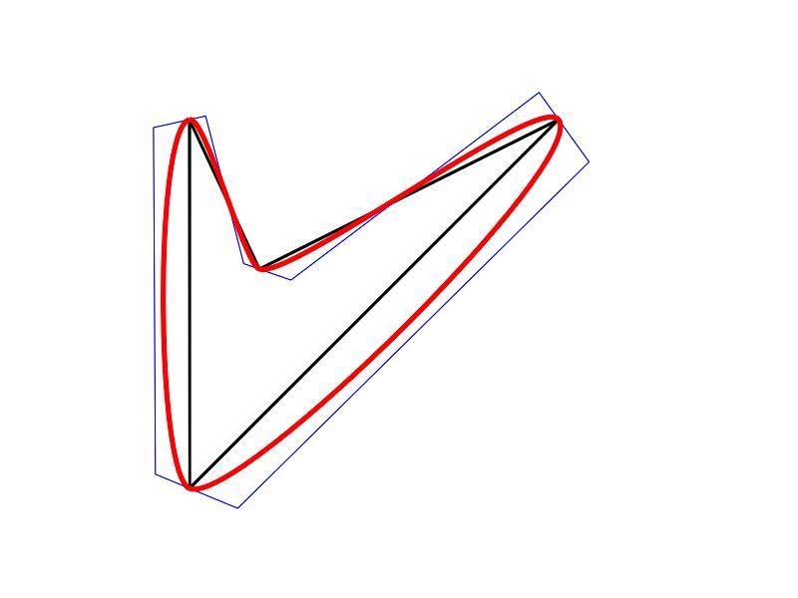
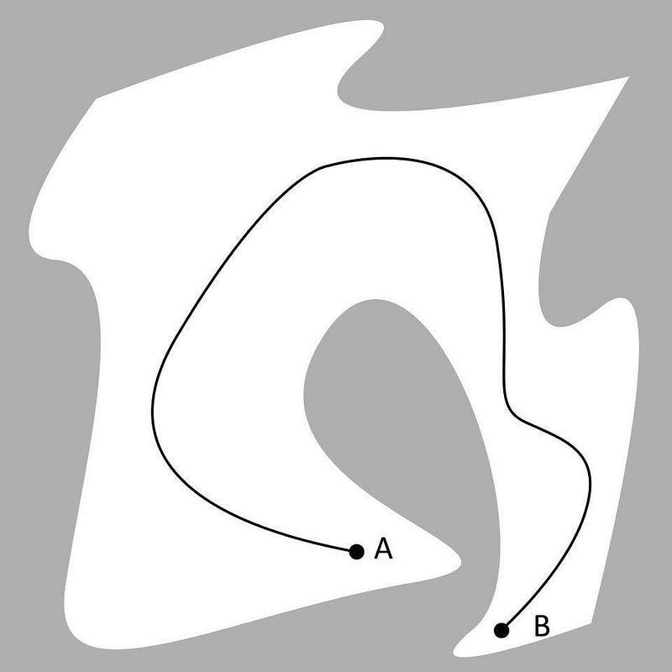
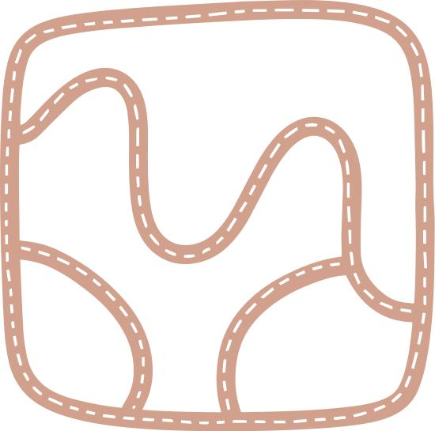
The curved portion may resemble natural forms such as:
- Branches
- Leaves
- Waves
- Natural contours

5. Polygon–Freeform Open Shapes
# Source: AI Source: Provided by: [Data Path: Persons Table -> ID Column: 1, Name_En Column: Motasem Essam] -> From: [ChatGPT] on [7/25/2026]
A straight-sided section is combined with one or more freely controlled curves.
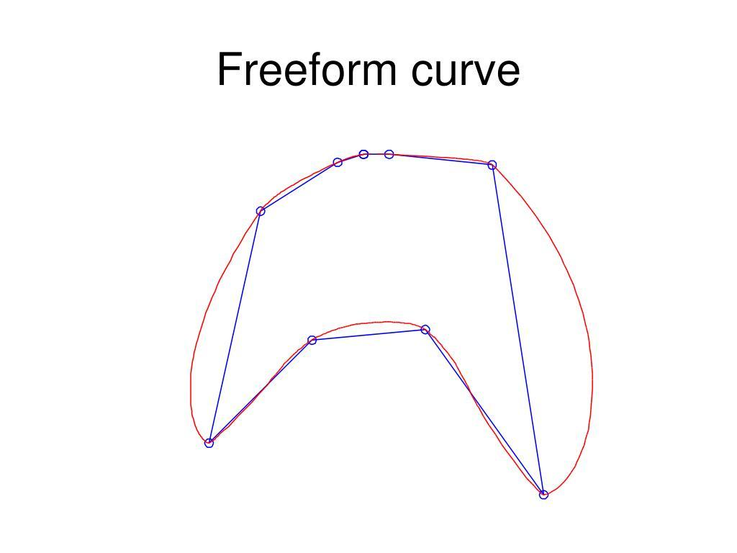
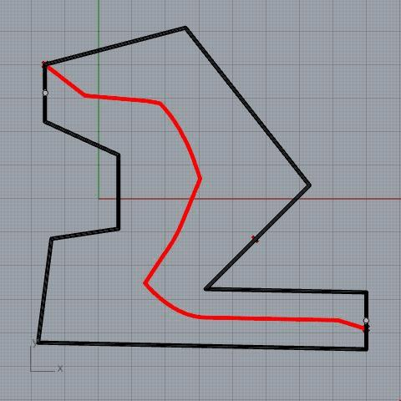
The freeform section may be created using:
- Bézier curves.
- Splines.
- CAD curves.
- Vector paths.

6. Circular–Organic Open Shapes
# Source: AI Source: Provided by: [Data Path: Persons Table -> ID Column: 1, Name_En Column: Motasem Essam] -> From: [ChatGPT] on [7/25/2026]
A circular arc is combined with a natural-looking irregular curve.
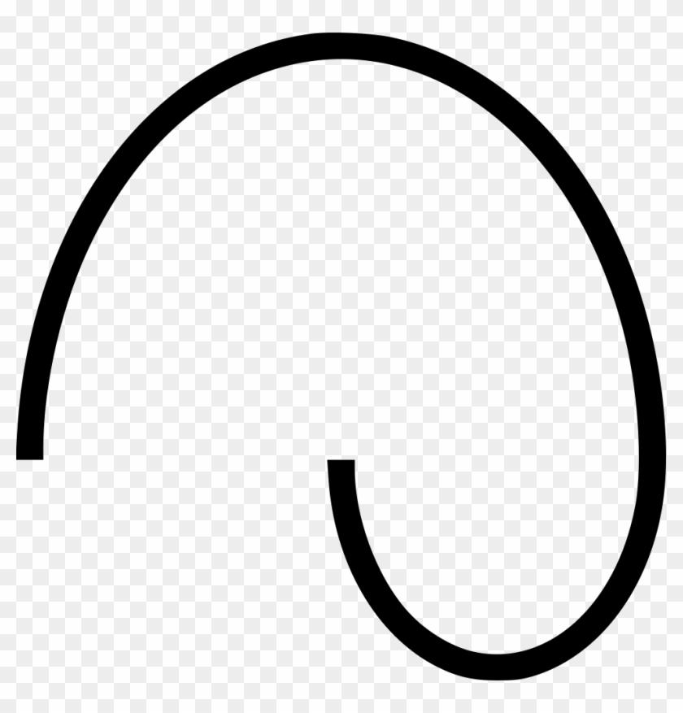
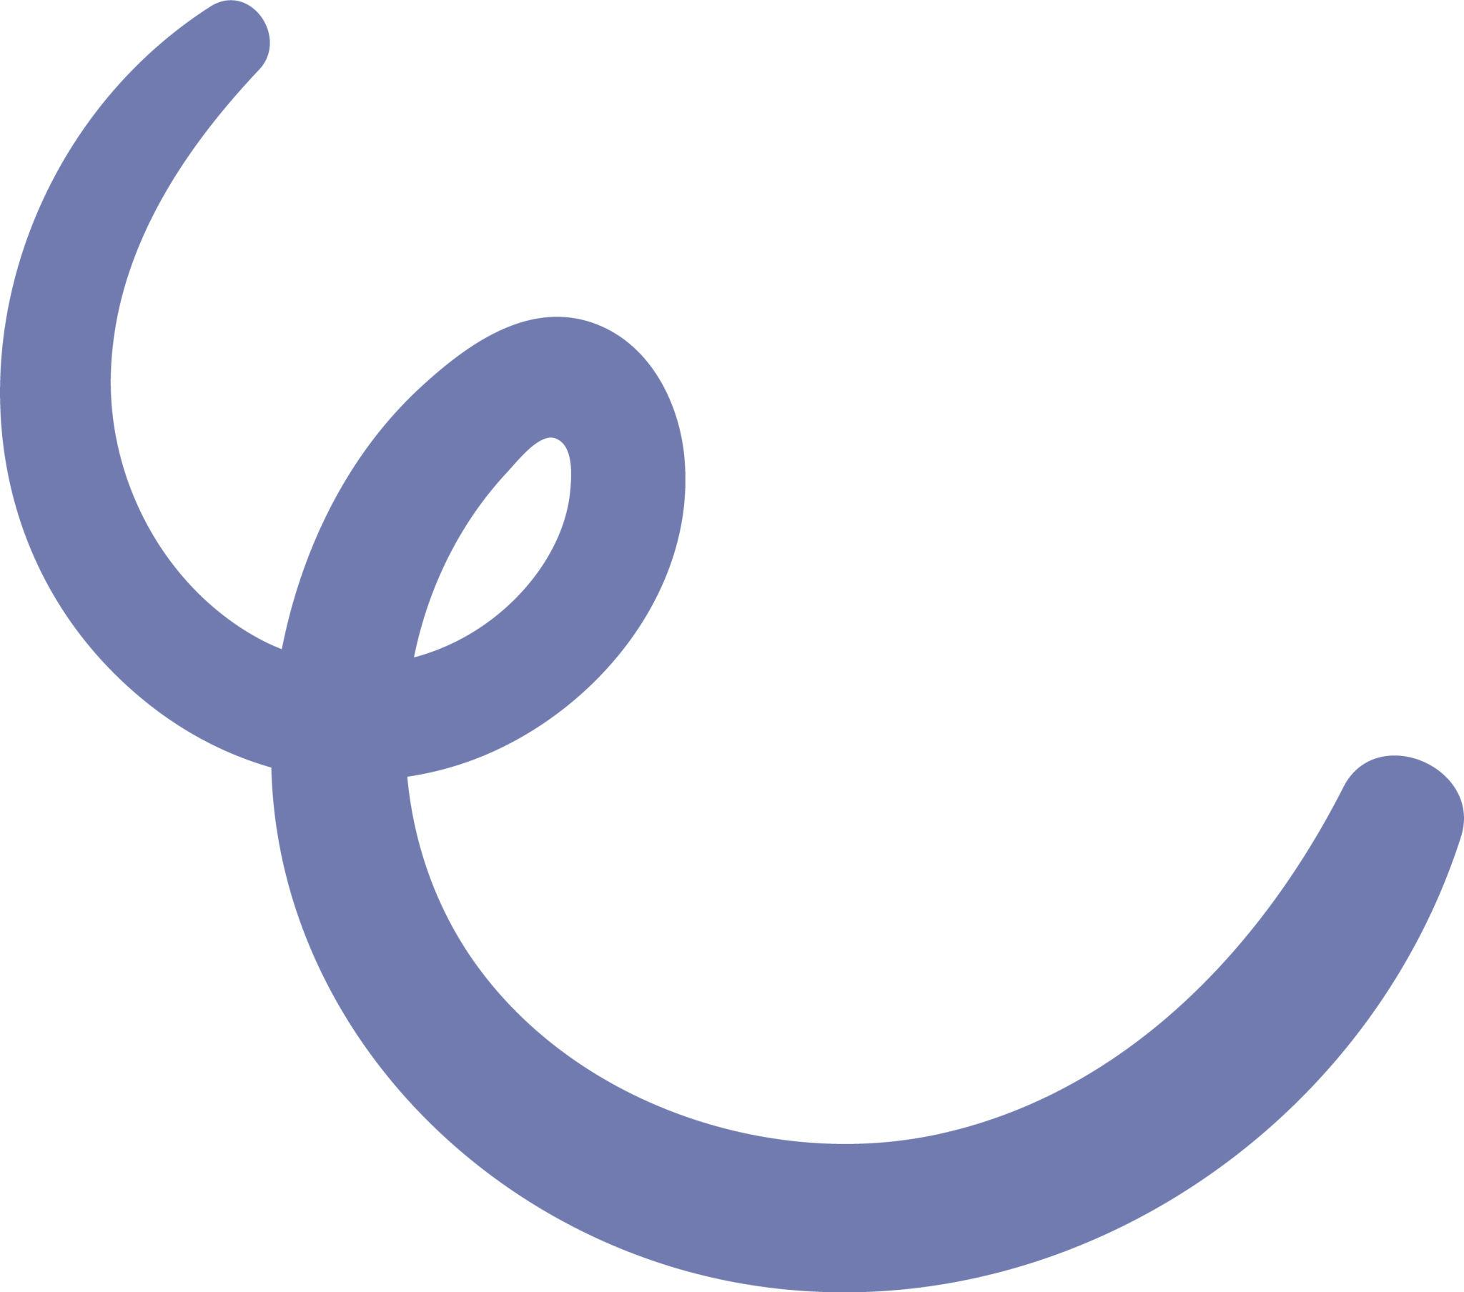
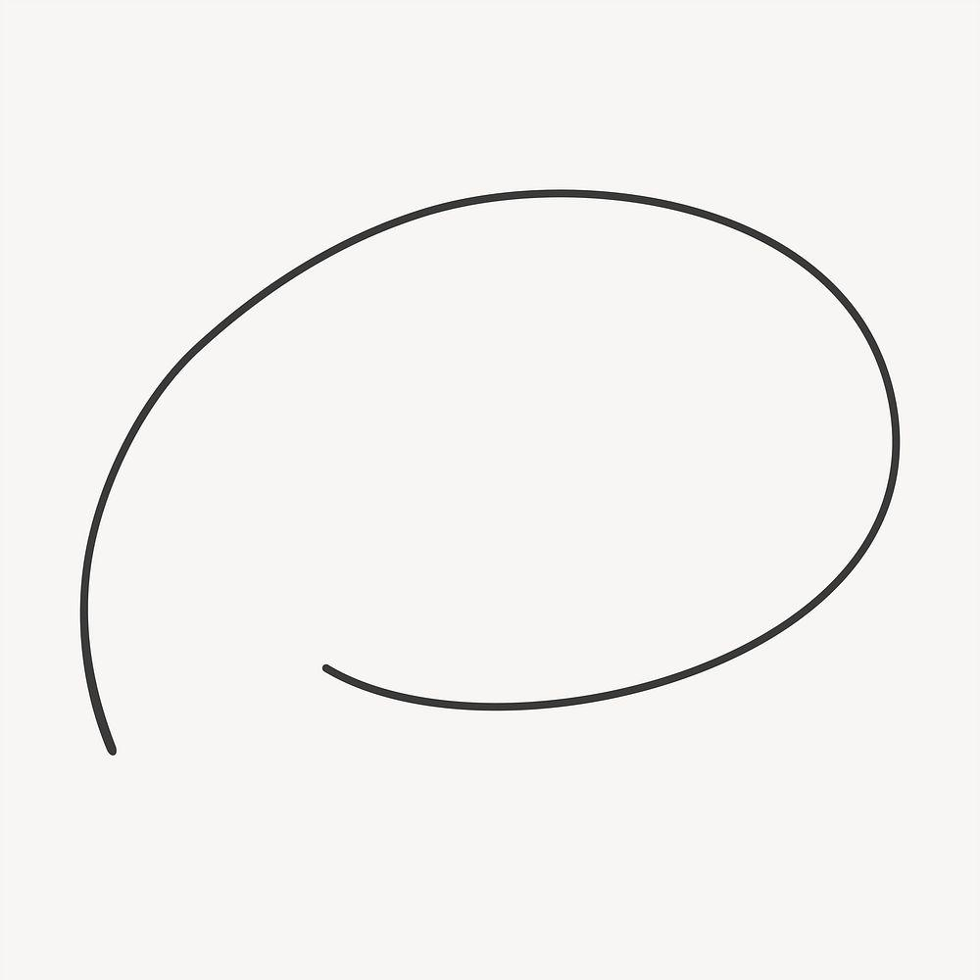
For example:
$$\text{Circular Arc}+\text{Organic Curve}$$

7. Circular–Freeform Open Shapes
# Source: AI Source: Provided by: [Data Path: Persons Table -> ID Column: 1, Name_En Column: Motasem Essam] -> From: [ChatGPT] on [7/25/2026]
A circular arc is combined with a freely designed curve.
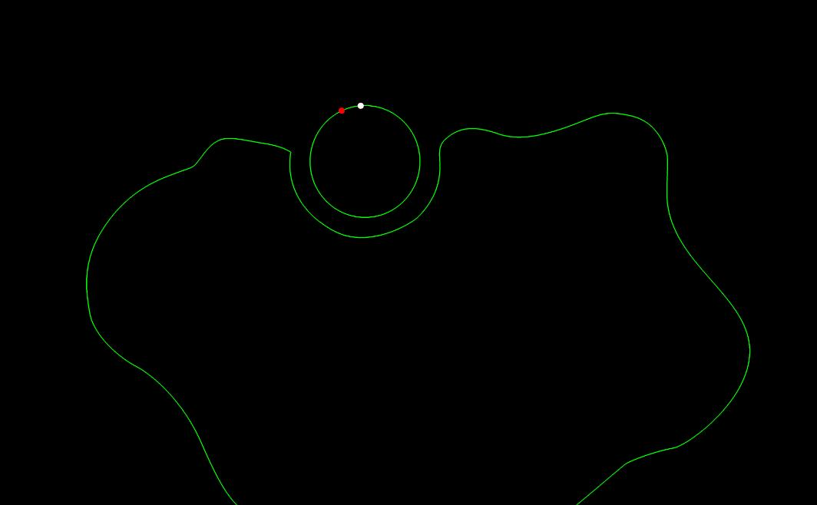
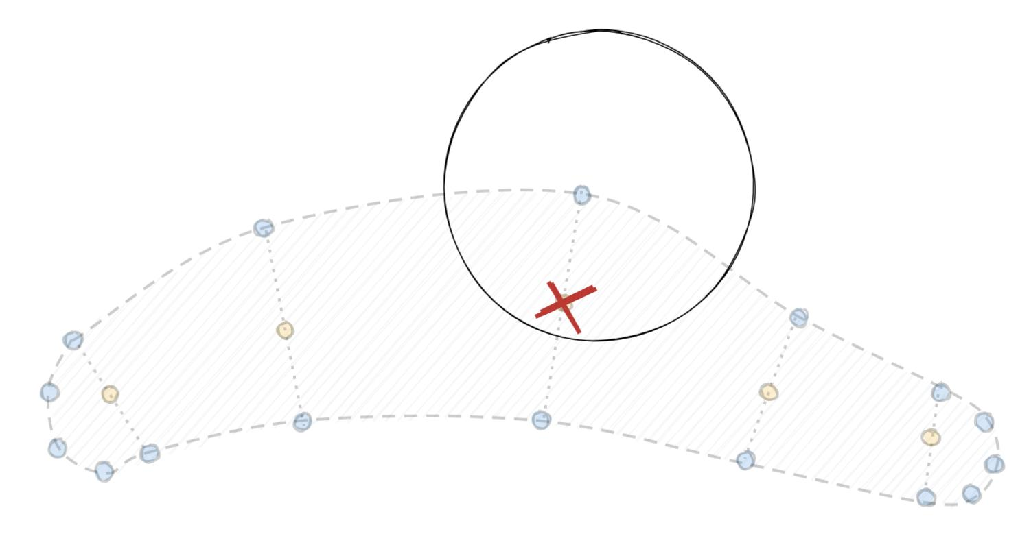
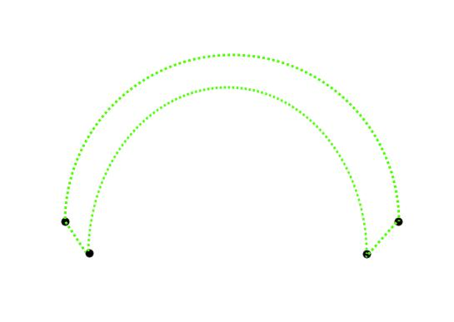
This is useful for custom technical and graphic-design paths.

8. Straight–Wavy Open Shapes
# Source: AI Source: Provided by: [Data Path: Persons Table -> ID Column: 1, Name_En Column: Motasem Essam] -> From: [ChatGPT] on [7/25/2026]
Straight segments are connected to irregular or wavy curves.
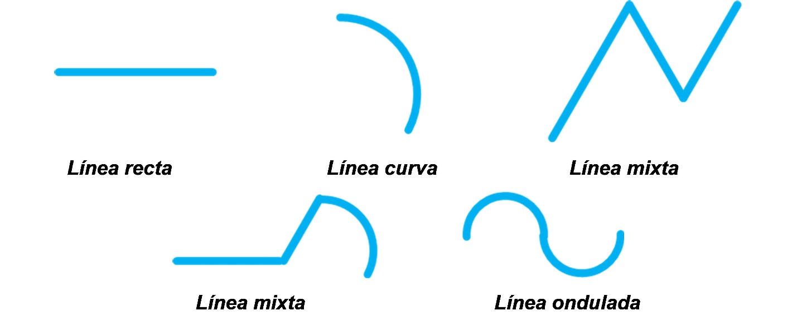
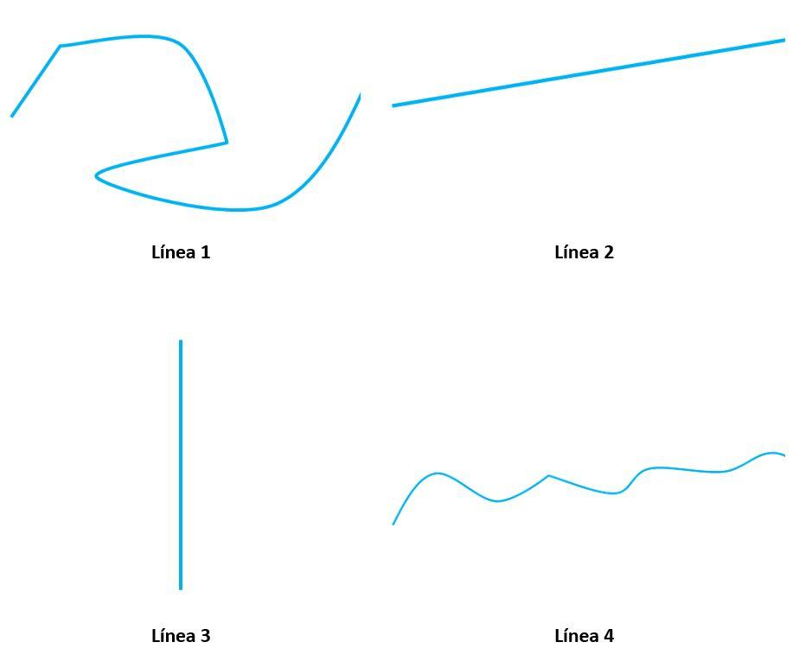
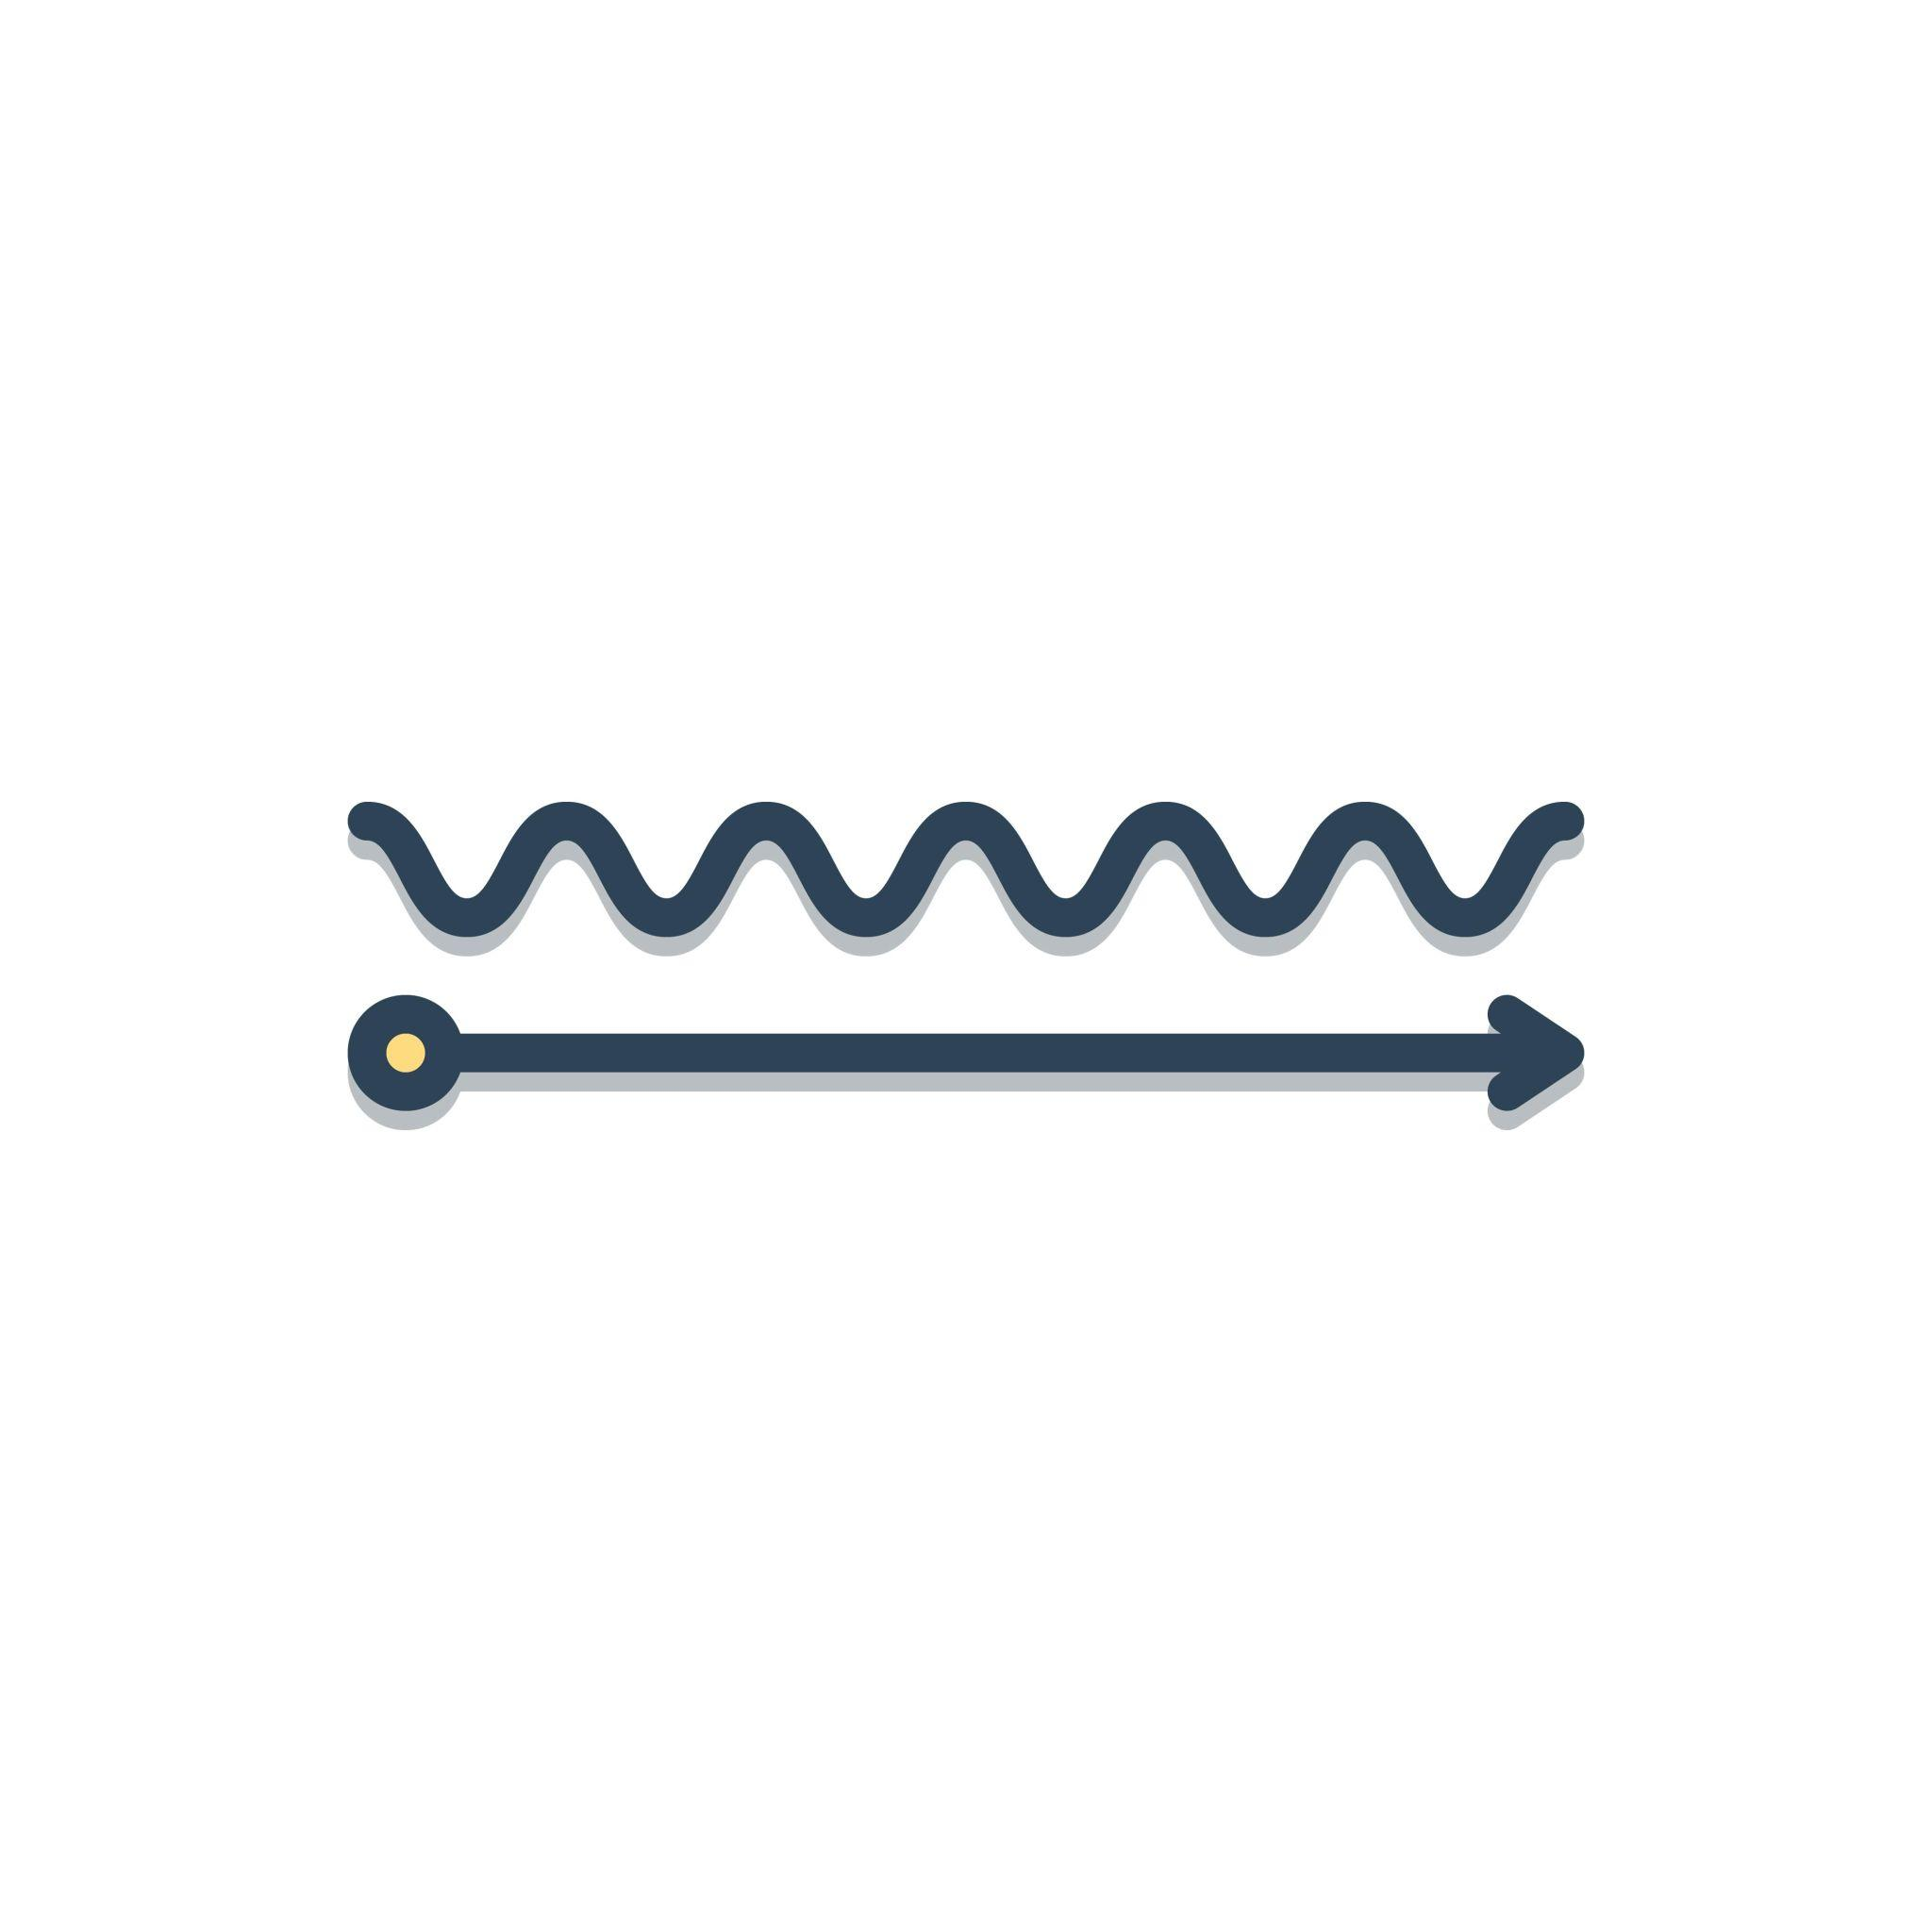
Example:
$$\text{Straight Segment}→\text{Wavy Curve}→\text{Straight Segment}$$

9. Polygon–Circular–Freeform Open Shapes
# Source: AI Source: Provided by: [Data Path: Persons Table -> ID Column: 1, Name_En Column: Motasem Essam] -> From: [ChatGPT] on [7/25/2026]
This is a more complex open mixed path containing:
- Straight polygonal segments.
- Circular arcs.
- Freeform curves.
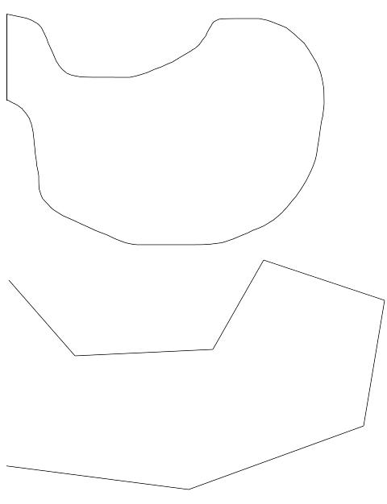
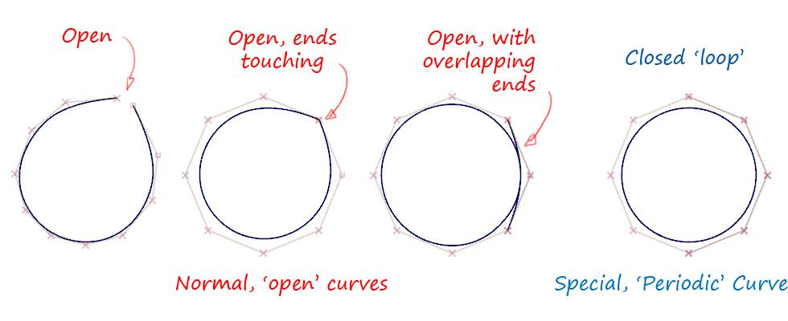
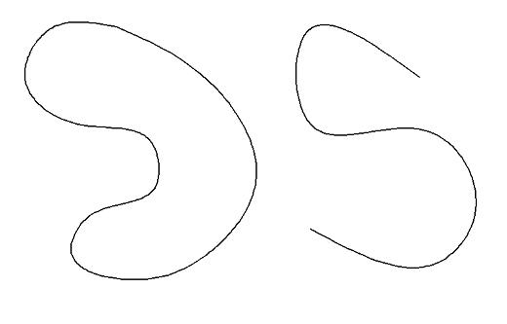
$$\boxed{\text{Polygonal}+\text{Circular}+\text{Freeform}}$$

Open Mixed vs. Open Polygonal Shapes
# Source: AI Source: Provided by: [Data Path: Persons Table -> ID Column: 1, Name_En Column: Motasem Essam] -> From: [ChatGPT] on [7/25/2026]
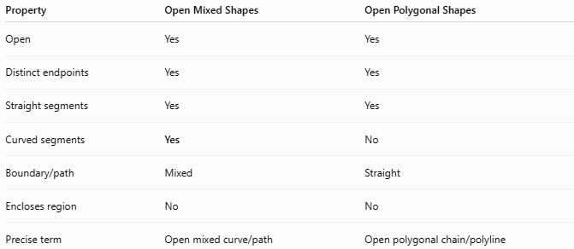
Property | Open Mixed Shapes | Open Polygonal Shapes
Open | Yes | Yes
Distinct endpoints | Yes | Yes
Straight segments | Yes | Yes
Curved segments | Yes | No
Boundary/path | Mixed | Straight
Encloses region | No | No
Precise term | Open mixed curve/path | Open polygonal chain/polyline
The key difference is:
$$\boxed{\text{Open Polygonal}=\text{Straight Only}}$$
while:
$$\boxed{\text{Open Mixed}=\text{Straight + Curved}}$$

Open Mixed vs. Open Curved Shapes
# Source: AI Source: Provided by: [Data Path: Persons Table -> ID Column: 1, Name_En Column: Motasem Essam] -> From: [ChatGPT] on [7/25/2026]
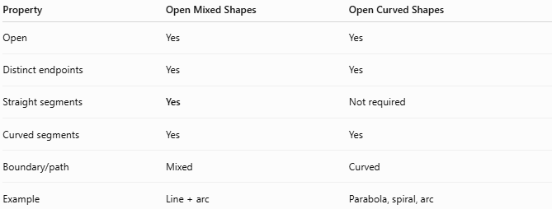
Property | Open Mixed Shapes | Open Curved Shapes
Open | Yes | Yes
Distinct endpoints | Yes | Yes
Straight segments | Yes | Not required
Curved segments | Yes | Yes
Boundary/path | Mixed | Curved
Example | Line + arc | Parabola, spiral, arc
Therefore:
$$\boxed{\text{Open Mixed}=\text{Straight + Curved}}$$
while:
$$\boxed{\text{Open Curved}=\text{Curved}}$$

Boundary / Path
# Source: AI Source: Provided by: [Data Path: Persons Table -> ID Column: 1, Name_En Column: Motasem Essam] -> From: [ChatGPT] on [7/25/2026]
Because the shape is open, its path does not return to its starting point.
For example:
$$P_{1}→P_{2}→P_{3}→P_{4}$$
where:
$$\boxed{P_{4}≠P_{1}}$$
The path may consist of different sections:
$$\boxed{\text{Straight Segments}∪\text{Circular Arcs}∪\text{Freeform Curves}}$$

Length
# Source: AI Source: Provided by: [Data Path: Persons Table -> ID Column: 1, Name_En Column: Motasem Essam] -> From: [ChatGPT] on [7/25/2026]
An open mixed shape can have a measurable total path length.
$$\boxed{L_{\text{total}}=L_{\text{straight}}+L_{\text{circular}}+L_{\text{freeform}}}$$
For a circular arc:
$$L_{\text{arc}}=rθ$$
For a freeform parametric curve:
$$L=\int_{a}^{b}{\sqrt{{\left(\frac{dx}{dt}\right)}^{2}+{\left(\frac{dy}{dt}\right)}^{2}}}dt$$

Area
# Source: AI Source: Provided by: [Data Path: Persons Table -> ID Column: 1, Name_En Column: Motasem Essam] -> From: [ChatGPT] on [7/25/2026]
An open mixed path does not enclose an area by itself:
$$\boxed{A_{\text{enclosed}}=\text{not defined}}$$
However, if the open mixed path is combined with additional segments that close it, the resulting closed region can have a measurable area.

Key Points
# Source: AI Source: Provided by: [Data Path: Persons Table -> ID Column: 1, Name_En Column: Motasem Essam] -> From: [ChatGPT] on [7/25/2026]
An Open Mixed Shape is:
$$\boxed{\text{Open}+\text{Straight}+\text{Curved}}$$
It has:
- Two distinct endpoints.
- Both straight and curved elements.
- No enclosed region by itself.
- A mixed path/boundary.
- A measurable total length.
- Potentially polygonal, circular, organic, wavy, or freeform sections.

Conclusion
# Source: AI Source: Provided by: [Data Path: Persons Table -> ID Column: 1, Name_En Column: Motasem Essam] -> From: [ChatGPT] on [7/25/2026]
Open Mixed Shapes are open geometric paths that combine straight-line segments with curved elements. They form a useful third category alongside Open Polygonal Shapes and Open Curved Shapes. Common subtypes include Polygon–Circular, Rectangle–Circular, Triangle–Circular, Polygon–Organic, Polygon–Freeform, Circular–Organic, Circular–Freeform, Straight–Wavy, and Polygon–Circular–Freeform Open Shapes.

